Onyx® New Brochure and Competitive Comparison Video

Superior Performance for Challenging Patient Conditions

The Nonin Onyx oximeter is known to many clinicians for its superior performance in patients with challenging conditions. We always need to remind our customers of why that is true. Sometimes a clinician may start wavering on the price, or a clinician may need support convincing purchasing or materials management to pay more for an Onyx. Use this brochure to tell the Nonin Onyx story and remind them why they should use Nonin pulse oximeters.

Onyx Brochure
Attached is a pdf of the new Nonin Onyx brochure. The brochure will be printed and available in mid-to-late October
- Inside fold-in page: this first page details the pathophysiology and comorbidities of a COPD patient and explains why it can be a challenge to get an accurate SpO₂ reading.
- Three-page spread: this spread is a summary of the benefits of Nonin technology and Onyx performance. It is the support for why Onyx is the right choice for patients with challenging conditions.
- Back page: this table compares professional grade pulse oximeter features between the Nonin Onyx and competitive brands. …such as if the oximeter is latex-free or RoHs complaint.

Competitive Comparison Video
Below are the directions for accessing a 2 minute video that shows the accuracy and durability of a Nonin Onyx finger pulse oximeter over other finger pulse oximeters. Download the video to show customers the Onyx superiority – a picture is worth a thousand words. (Note: This audio-free video is a great opportunity for you talk through it with your customers.)

The oximeter a clinician uses needs to work on all patients – especially those with challenging conditions. Use this brochure and video to help remind people of the Nonin Onyx benefits and why they should use a Nonin Onyx finger pulse oximeter.

Good Selling !

Mark
Mark Goldberg
Nonin Fingertip Product Manager

Competitive Comparison Video

Video viewing instructions:
The video is available for viewing on the Nonin Medical Channel on YouTube. You can reach the video through this address:
http://youtu.be/B_dO-gPkDTc
(Please note the address is “youtu.be” and the “O” is the letter O not the number zero.)

Video Download Instructions:
There is one video available in three formats. They are labeled:
• Nonin Onyx Vantage Video QuickTime - a QuickTime .mov file.
• Nonin Onyx Vantage Video mp4 – a mp4 file for ipads and other apple products
• Nonin Onyx Vantage Video - a .wmv file and is a Windows Media Video file.

To reach the videos on the FTP site click the link below:
ftp://cconyxvantage:cresc744@ftp.nonin.com

OR TRY:
ftp://ftp.nonin.com/
with
Username: cconyxvantage
Password: cresc744

Once you reach the FTPs site you will see the screen below. Click on the folder: “NEW Onyx Vantage Video”
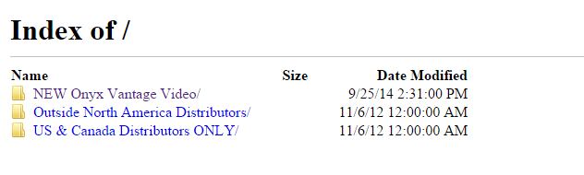

Once you open the folder you will see the screen below. You can click on a file to view it or right click on a file and select “Save link as…” and save it to your computer. Whether you are saving the file or viewing it, it may take a few minutes to download as each file is approximately 30MB.
